**GrowMate**

A Project Report

submitted in partial fulfillment of the requirements

of

Artificial Intelligence with Cloud Computing

by

**Harshal Borkar, 20010850**

**Sankit Binkar, 20010825**

**Rohit Kirpal, 20010314**

**Harsh Ghatode, 20010021**

**Aditya Mate, 20010893**

Under the Esteemed Guidance of

**Akshay Chaskar**

**ACKNOWLEDGEMENT**

We extend our heartfelt gratitude to all individuals who have directly or indirectly contributed to the development of our project, GrowMate- an innovative web application that leverages Machine Learning algorithms to provide crop recommendations and plant disease identification.

First and foremost, we express our sincere appreciation to our supervisor, **Akshay Chaskar,** whose mentorship and guidance have been invaluable. His insightful advice, unwavering encouragement, and constructive feedback have fueled our creativity and propelled us toward the successful completion of this dissertation. His belief in our abilities has been a constant source of inspiration throughout this journey. It has been privilege working with him under his guidance from last few days. He has always helped us in every aspect of project work. He has never failed in solving my queries. His engaging discussions and enlightening lessons not only enriched our thesis work but also shaped us into conscientious professionals.To all those who contributed to GrowMate, directly or indirectly, we express our deepest gratitude. Together, we strive to enhance crop production, empower farmers, and make a positive impact in the agricultural domain.

#### **ABSTRACT**

GrowMate is an innovative web application designed to revolutionize agricultural decision making by assisting farmers in optimizing their crop selection for their farm and protecting the crop plants from disease. Leveraging Machine Learning Algorithms, GrowMate analyses crucial input parameters such as Nitrogen, Phosphorous, Potassium, Temperature, Humidity, Soil pH, and Rainfall to recommend the most suitable crop for cultivation. Additionally, it provides the suitable fertilizers respective to the crop recommended along with brief description about fertilizers, ensuring healthy plant growth and resource efficiency. Along with crop recommendation, GrowMate comes with the plant disease identification system, which helps the farmer to detect the crop disease just by uploading the image of respective infected plant leaf. In addition to that, it will suggest the corresponding supplements for the plant disease. This proposed system aims to empower farmers with data driven insights to enhance agricultural decision making, and promote sustainable farming practices.

**TABLE OF CONTENTS**

Abstract ………………………………………………………………………………………. 3

List of Figures ………………………………………………………………………………… 5

**Chapter 1.**  **Introduction**  **6**

1.1 Problem Statement 7

1.2 Problem Definition 7

1.3 Expected Outcomes 7

**Chapter 2.**  **Proposed Methodology**  **9**

2.1 System Design …………………………………………………………………. 10

2.2 Modules Used ………………………………………………………………….. 11

2.3 Advantages …..…………………………………………………………………. 12

2.4 Requirement Specification ……………………………………………………... 14

**Chapter 3.**  **Implementation and Results ……………………………………………………**   **15**

3.1. Crop Recommendation ………………………………………………………….. 17

3.2. Disease Identification ……………………………………………………………. 17

**Chapter 5.**  **Conclusion …………………………………………………………….................**  **18**

**GitHub Link …………………………………………………………………………………. 21**

**Video Link …………………………………………………………………………………… 21**

**References ……………………………………………………………………………………. 22**

**LIST OF FIGURES**

|  |  |  |
| --- | --- | --- |
| **Sr.no** |  | **Page No.** |
|  | System Design | 12 |
|  | Growmate Dashboard | 18 |
|  | Crop Recommendation | 19 |
|  | Disease Identifier | 19 |

**CHAPTER 1**

**INTRODUCTION**

**CHAPTER 1**

**INTRODUCTION**

1. **Problem Statement:**

Farmers face challenges in optimizing crop selection to maximize yield while efficiently utilizing resources. Existing methods often lack precision and fail to account for various environmental factors. It is also difficult to identify disease and its cure. Farmers are also not aware of new techniques and technologies. In addition to this, farmers are unable to find expert help for this.

1. **Problem Definition:**

Farmers struggle to select suitable crop for their farm according to soil conditions, climate, and available resources. Existing methods lack data-driven insights, hindering informed decision-making. GrowMate seeks to bridge this gap by providing personalized crop recommendations based on machine learning algorithms. It also addresses the need for precise fertilizer guidance to optimize crop health.

* 1. **Expected Outcomes:**
* **Precise Agriculture Guidance**: Farmers will have access to personalized recommendations for crop selection, nutrient management, and optimal planting practices.
* **Integrated Disease Management**: Early detection and prevention of plant diseases will minimize crop losses.
* **Increased Crop Yield**: By making informed decisions, farmers will achieve higher yields and economic stability.
* **User-Friendly Platform**: GrowMate’s intuitive interface will empower farmers of all backgrounds to navigate and utilize its features effectively.
* **Showcasing New Techniques**: Farmers can explore innovative cultivation methods, enhancing productivity.
* **Government Scheme Information**: GrowMate will disseminate information about agricultural subsidies, grants, and government programs.
* **Sustainable Advocacy**: By promoting sustainable practices, GrowMate contributes to environmental conservation and long-term agricultural viability.
* **Continuous Improvement**: GrowMate will evolve based on user feedback, incorporating new research and advancements.
* **Resource Efficiency**: Optimal practices reduce resource wastage (water, fertilizers, etc.).

**CHAPTER 2**

**PROPOSED METHODOLOGYCHAPTER 2**

**PROPOSED METHODOLOGY**

**2.1 System Design**

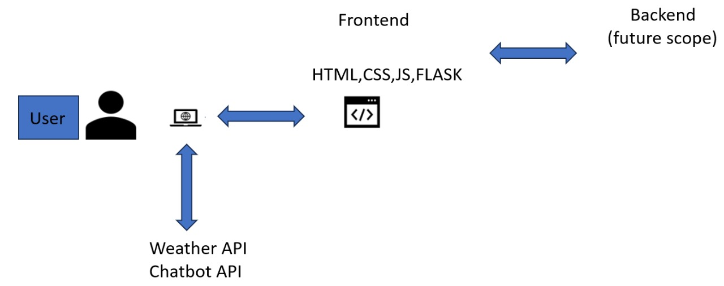

**Figure No. 2.1. System Design**

The client can navigate to the website by using the web app link. This whole web app built using the web technologies such as HTML, CSS, JavaScript, Python Flask and various inbuilt python modules. On visiting, client will be redirected to dashboard page where there is live weather and location information is displayed by using OpenWeatherAPI key. Addition to this, there is a chatbot which can be used to get the answer to clients every question. This chatbot is implemented by using OpenAI API key. Similarly, there are various tabs given within the web app. There is two major tabs within webapp which are crop recommendation and disease identifier. The Machine Learning algorithms are also used to create ML models which gives the desired output results.

* 1. **Modules Used**

The following Python modules were used in building our Growmate web app:

* **NumPy:** A powerful library for numerical computations, providing support for arrays, matrices, and mathematical functions.
* **Pandas:** Used for data manipulation and analysis, Pandas simplifies working with structured data through DataFrames.
* **Scikit-Learn (SkLearn):** An essential toolkit for machine learning tasks, including classification, regression, and clustering algorithms.
* **TensorFlow/Keras:** These deep learning libraries enable the creation and training of neural networks for tasks like image recognition and natural language processing.
* **Flask:** Our lightweight web framework for handling routing, server-side logic, and API communication.
* **Pickle:** A Python module for serializing and deserializing Python objects, essential for model persistence.
* **OS and Time:** These built-in modules facilitate file operations, system interactions, and time-related tasks.
* **OpenAI:** Powering our intelligent chatbot, OpenAI provides natural language understanding and prompt-based responses.

These modules collectively contribute to the functionality and efficiency of our web application.

* 1. **Advantages:**

The GrowMate project is a comprehensive web application designed to revolutionize farming practices and empower agricultural communities. By leveraging cutting-edge technologies and data-driven approaches, GrowMate offers several key advantages:

1. **Data-Driven Crop Selection:** 
   * + **Machine Learning Algorithms:** GrowMate analyzes critical input parameters, including nitrogen levels, phosphorous content, potassium availability, temperature, humidity, soil pH, and rainfall patterns. Based on this data, it recommends the most suitable crops for cultivation.
     + **Informed Decision-Making:** Farmers receive precise guidance on which crops to grow, leading to better yields and optimal resource utilization. The data-driven approach ensures that every planting decision is backed by science.
2. **Plant Disease Identification System:** 
   * + **Game-Changing Feature:** The integrated disease identification system allows farmers to quickly diagnose plant health issues.
     + **Simple Process:** Farmers upload images of infected plant leaves, and GrowMate rapidly identifies the disease.
     + **Timely Intervention:** Early detection enables timely intervention, preventing further spread and minimizing crop losses.
3. **Supplement Suggestions:**

Not only does GrowMate identify plant diseases, but it also suggests corresponding supplements to address the issue. Whether it’s a nutrient deficiency or a specific treatment, farmers receive actionable recommendations to protect their crops.

1. **Empowering Farmers:**
   * + **Knowledge is Power:** By providing data-driven insights, GrowMate empowers farmers to make informed decisions.
     + **Effective Crop Management:** Improved yield management, resource optimization, and sustainable practices contribute to the overall well-being of the agricultural sector.
2. **Tailored Fertilizer Recommendations:**
   * + **Crop-Specific Advice:** Beyond crop selection, GrowMate provides personalized fertilizer recommendations. Depending on the chosen crop, farmers receive guidance on the appropriate fertilizers to use.
     + **Healthy Plant Growth:** Proper nutrient utilization promotes robust plant growth, healthier produce, and sustainable farming practices.
3. **User Experience and Navigation:**
   * + Upon accessing the web app, users are seamlessly redirected to the dashboard.
     + Clear navigation tabs guide users to specific functionalities: weather, chatbot, crop recommendations, and disease identification.
     + The intuitive design ensures a user-friendly experience, even for those with minimal technical expertise.
4. **Live Weather and Location Information:**

Upon visiting the dashboard, users are greeted with real-time weather updates and their current location. We achieve this by integrating the OpenWeatherAPI.

1. **Chatbot:**

Our intelligent chatbot, powered by the OpenAI API, assists users by answering their queries. Whether it’s crop-related advice, weather forecasts, or general information, the chatbot provides prompt responses.

* 1. **Requirement Specification**
     1. **Hardware Requirements:**
  + **Processor:** intel core i5 or higher.
  + **RAM:** 16 GB or above.
  + **Hard Drive:** Minimum 50 GB.
  + **Network:** Local area network (LAN).
    1. **Software Requirements:**
  + **Operating System:** Windows 10 or above.
  + **Front End Development:** HTML, CSS, JavaScript, Python, Flask.
  + **Editors and IDE:** Visual Studio Code Editor, Jupyter Notebook.
  + **Web Browsers:** Microsoft Edge, Google Chrome, Internet Explorer, etc.

**CHAPTER 3**

**IMPLEMENTATION AND RESULT**

**CHAPTER 3**

**IMPLEMENTATION & RESULT**

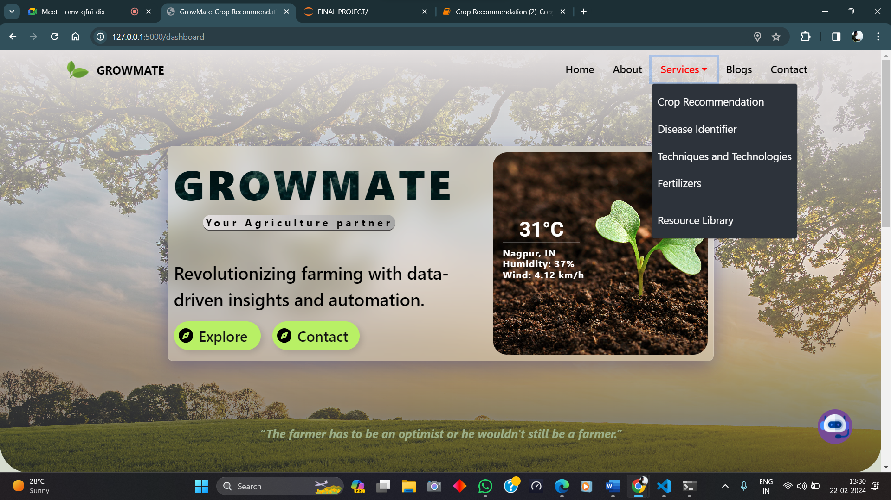

**Figure No. 3.1. Growmate Dashboard**

* 1. **Results of Crop Recommendation.**

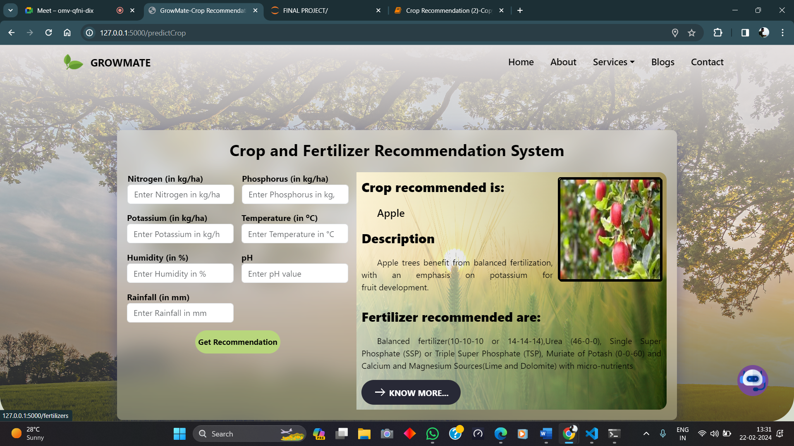

**Figure No. 3.2. Crop Recommendation**

* 1. **Results of Plant Disease Identifier.**

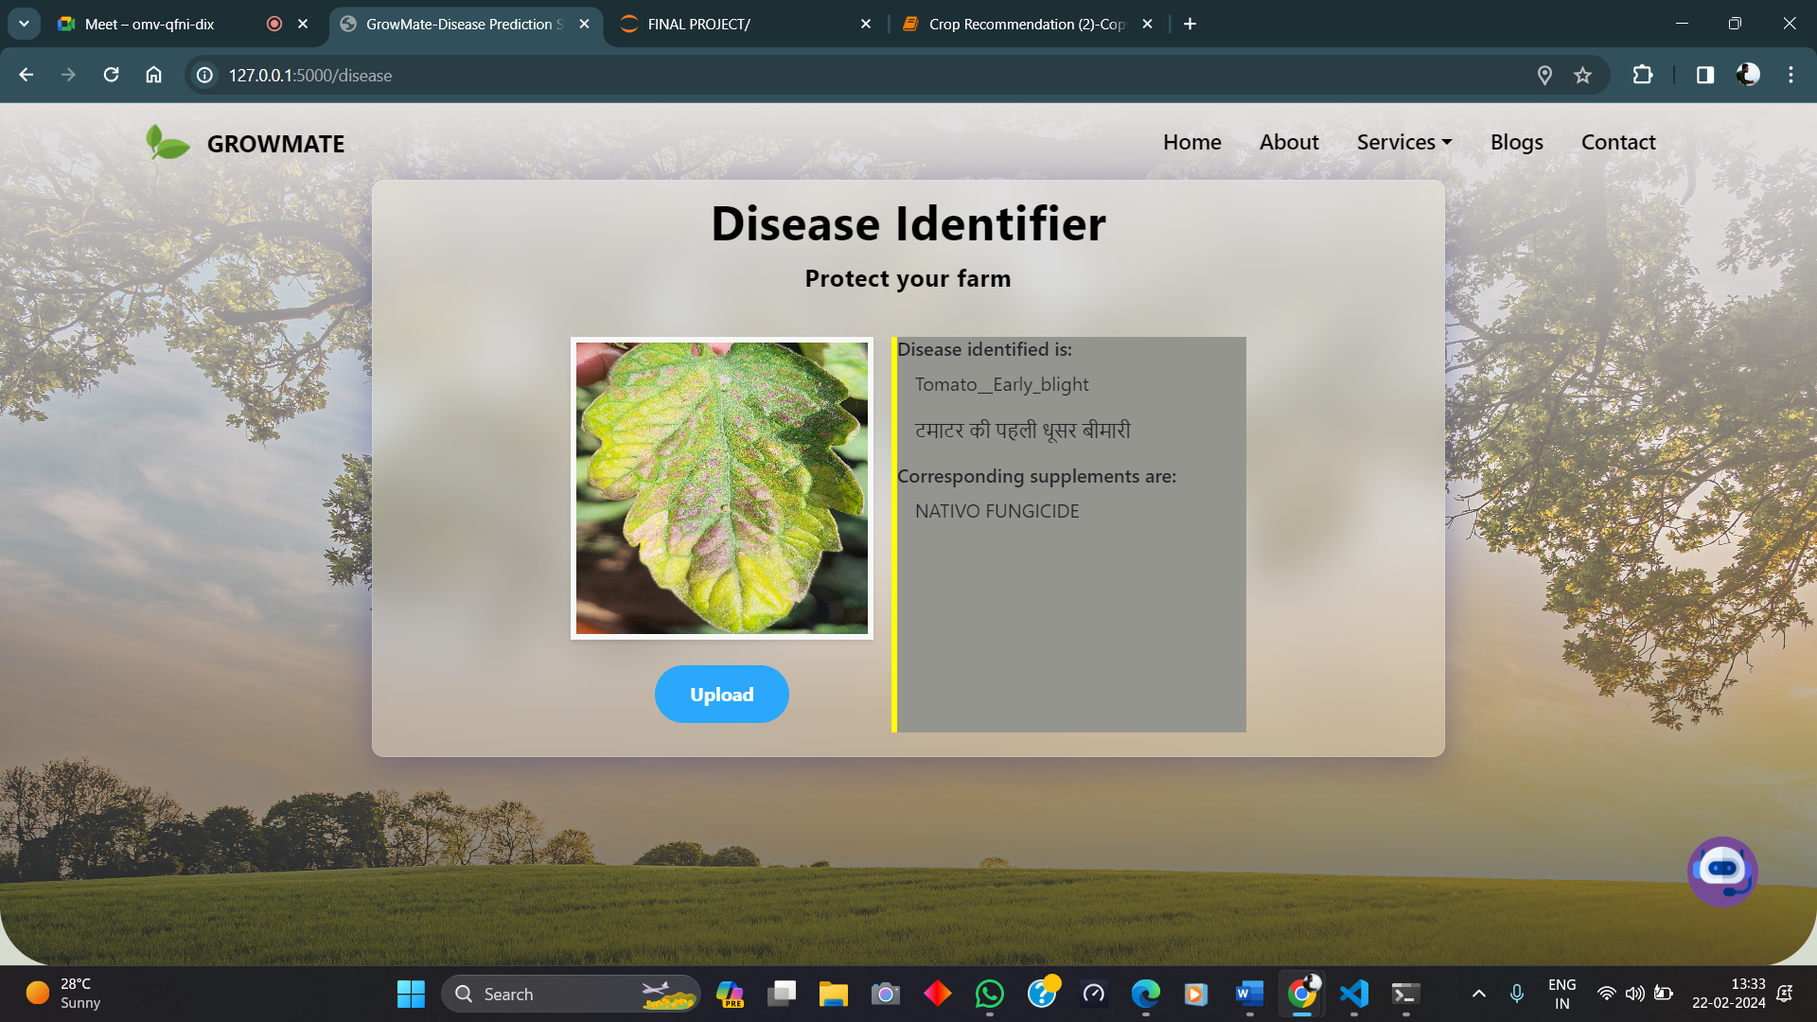

**Figure No. 3.3. Plant Disease Identifier**

**CHAPTER 4**

**CONCLUSIONCHAPTER 5**

**CONCLUSION**

**5.1 ADVANTAGES:**

1. **Data-Driven Crop Selection**
2. **Plant Disease Identification System**
3. **Supplement Suggestions**
4. **Empowering Farmers**
5. **Tailored Fertilizer Recommendations**
6. **User Experience and Navigation**
7. **Live Weather and Location Information**
8. **Chatbot**

**5.2 FUTURE SCOPE:**

As we look ahead, the GrowMate project has exciting opportunities for expansion and improvement. Here are the key areas of focus:

* **Land Type Integration:**

**Objective:** Incorporate land type analysis to enhance crop recommendations.**Approach:** Utilize soil data, topography, and geographical information to tailor crop suggestions based on specific land characteristics.**Benefits:** Farmers receive personalized advice, optimizing crop yield and resource utilization.

* **Organic Farming Techniques:**

**Objective:** Promote sustainable and eco-friendly practices.**Implementation:** Integrate organic farming guidelines within the app. Provide tips on natural pest control, composting, and soil enrichment. Highlight the benefits of organic farming for soil health and biodiversity.**Impact:** Empower farmers to adopt environmentally conscious methods.

* **Access to Government Schemes and Subsidies:**

**Objective:** Simplify access to agricultural subsidies and support.**Features:** Create a dedicated section within the app for government schemes. Provide information on eligibility criteria, application procedures, and deadlines. Enable users to apply directly through the app.**Advantages:** Streamlined processes, increased awareness, and financial assistance for farmers.

* **Database Integration:Objective:** Enhance data management and scalability.**Implementation:** Set up a robust database system (e.g., MySQL, PostgreSQL). Store user profiles, historical weather data, and crop-related information. Ensure efficient retrieval and update mechanisms.**Benefits:** Improved performance, personalized experiences, and data-driven insights.
* **Collaboration with Agricultural Research Institutes:Objective:** Foster partnerships with research institutions.**Actions:** Collaborate on crop modeling, disease prediction, and sustainable practices. Access cutting-edge research and incorporate findings into the app. Conduct joint workshops and training sessions for farmers.**Outcomes:** Continuous learning, innovation, and community engagement.
* **Mobile App Extension:Objective:** Reach a wider audience through mobile devices.**Development:** Create a mobile version of GrowMate (iOS and Android). Optimize for smaller screens and touch interactions. Include push notifications for weather alerts, disease outbreaks, and subsidy updates.**Impact:** Increased accessibility and user engagement.

**5.3 CONCLUSION:**

GrowMate: Machine Learning based system provides a robust and data-driven approach for farmers to make informed decisions, fostering sustainable agriculture practices and optimizing crop yield in varying environmental conditions. This tool contributes to the modernization of farming strategies.

**GitHub Link:**

<https://github.com/harshal8668/GrowMate.git>

**Video Link:** <https://drive.google.com/drive/folders/1fluB6CKoGuwONcMBb2B9x5jPQn5Oz5Wc>

**REFERENCES**

1. Nishant, Potnuru Sai, Pinapa Sai Venkat, Bollu Lakshmi Avinash, and B. Jabber. "Crop Yield Prediction based on Indian Agriculture using Machine Learning." In 2020 International Conference for Emerging Technology (INCET), pp. 1-4. IEEE, 2020.
2. Kale, Shivani S., and Preeti S. Patil. "A Machine Learning Approach to Predict Crop Yield and Success Rate." In 2019 IEEE Pune Section International Conference (PuneCon), pp. 1-5. IEEE, 2019.
3. Notebooks: <https://www.kaggle.com/code/atharvaingle/plant-disease-classification-resnet-99-2> <https://www.kaggle.com/code/emmarex/plant-disease-detection-using-keras>
4. Plant disease identification: <https://youtu.be/amt9ZmGofJk?si=9LOTxHuG9QbPS7ok>
5. Crop recommendation: <https://youtu.be/_R9Q_iuyvdc?si=-irNlQ94o9C8IEHs>
6. <https://www.wikipedia.org/>